Deployed Front-End Evidence
This document shows that the Innovatech web tier is deployed with Terraform and is working.

1. Web Servers (Terraform)

1.1 Launch Template
The launch template describes what each web server looks like. Every server the Auto Scaling group creates is built from it, so all servers are identical. Each server is a t3.micro instance running the same Amazon Linux image as the database. It uses the web security group, which only allows HTTP from the load balancer subnets and metrics from monitoring. The disk is encrypted, and IMDSv2 is required. The SSM instance profile allows management through Session Manager and lets the server read the database password.
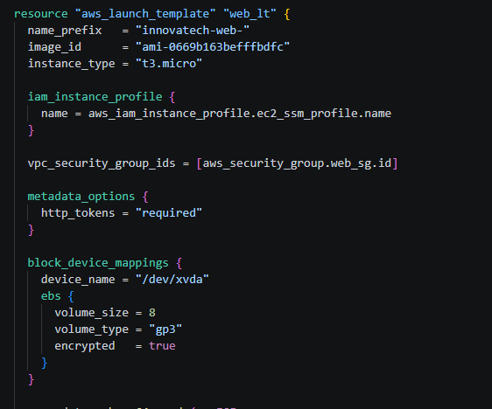
Figure 1: 4-web-launch-template.tf: launch template for the web servers

1.2 Automated Server Setup
The user_data script sets up each new server with no manual work. It installs nginx, the MySQL driver and later on the monitoring. It then fetches the database password from SSM Parameter Store and writes the connection details to /etc/innovatech/db.ini, which only root and the web server can read. Finally, it installs the nginx PHP configuration and the web page, and restarts the services. A new server is serving the website a few minutes after it starts.
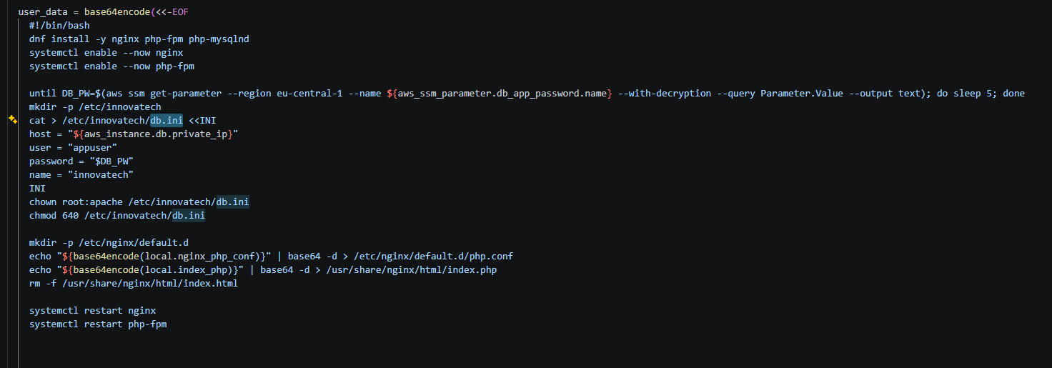
Figure 2: 4-web-launch-template.tf: user_data script that installs and configures each web server

2. Scalability: Auto Scaling Group
The Auto Scaling group keeps the web tier the right size and replaces broken servers automatically:
• Size: at least 2 servers and at most 4. The servers are spread over two subnets in different availability zones (web_a in eu-central-1a, web_b in eu-central-1b), so the site stays up if one zone fails.
• Health checks: health_check_type = "ELB" means a server counts as healthy only when the load balancer confirms it is serving pages, not just when the instance is running. A server that fails is replaced.
• Updates: the group uses an exact launch template version. Any change to the template therefore starts a rolling instance refresh, which replaces servers one at a time while at least 50% stay in service.
• Lifecycle hooks: these pause each server while it starts and stops, so it can be added to or removed from the load balancer safely
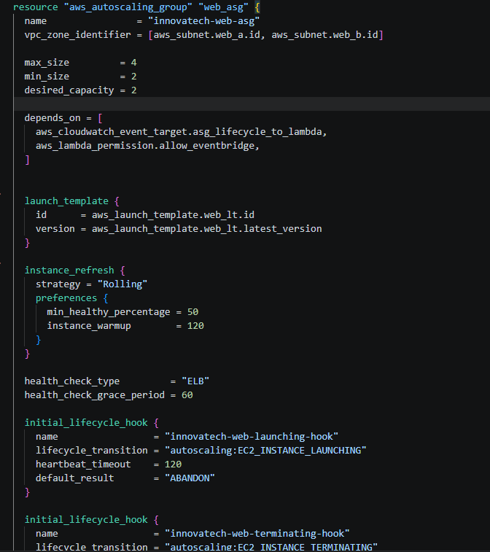
Figure 3: 4-web-asg.tf: Auto Scaling group with capacity, health checks, rolling refresh and lifecycle hooks

3. Load Balancer (Terraform)
The Application Load Balancer is the single public entry point to the website. It is internet-facing, sits in both DMZ public subnets (one per availability zone) and uses the ALB security group, which only allows HTTP on port 80. Its listener on port 80 forwards every request to the innovatech-web-tg target group.
The target group checks every server by requesting "/" every 30 seconds. A server receives traffic only after 2 successful checks in a row, and is taken out after 2 failed checks. The target type is "ip" because the load balancer is in the DMZ VPC while the web servers are in the Internal VPC. The load balancer reaches them through the Transit Gateway using their private IP addresses.
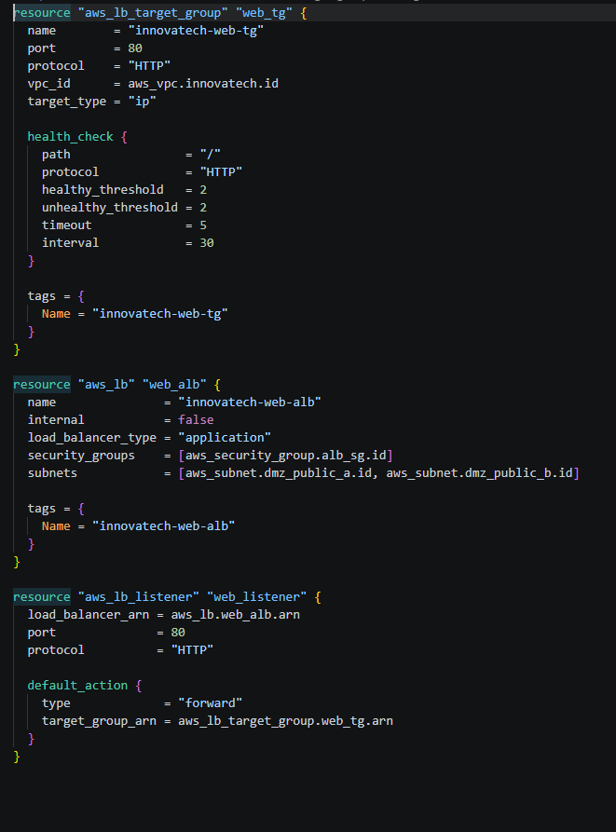
Figure 4: 4-web-load-balancer.tf: target group with health check, load balancer and listener

4. Automatic Registration of Web Servers
AWS can only add servers to a load balancer automatically when they are in the same VPC. Here the servers are in a different VPC, so the project registers them itself:
1. When the Auto Scaling group launches or terminates a server, the lifecycle hook pauses it and sends an event.
2. An EventBridge rule catches the launch and terminate events from innovatech-web-asg only, and passes them to the innovatech-target-registration Lambda function.
3. On launcch, the Lambda registers the new server’s private IP in the target group and lets the launch continue. On terminate, it removes the IP first, so visitors are not sent to a server that is shutting down.
If registration fails, the launch hook’s default result is ABANDON, so the server is removed instead of being left running unused.
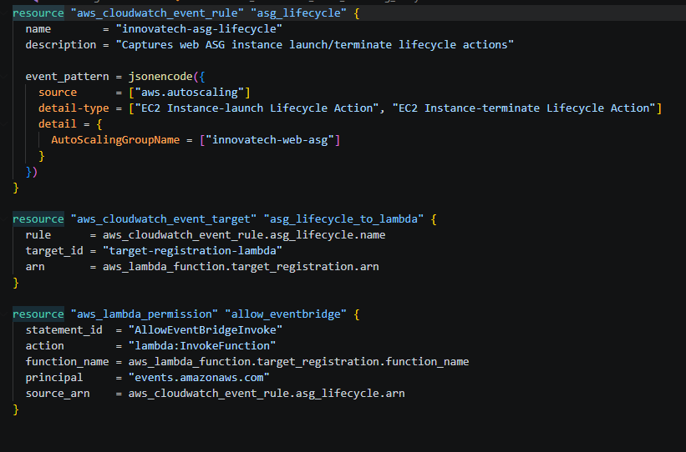
Figure 5: 4-web-target-events.tf: EventBridge rule that sends Auto Scaling lifecycle events to the registration Lambda

5. Deployed Front-End (AWS Console)

5.1 Auto Scaling Group
The innovatech-web-asg group is at its desired capacity, with 2 of 2 servers healthy. It uses a launch template version created by Terraform during the deployment.
Figure 6: AWS console: innovatech-web-asg at desired capacity, 2/2 healthy
The capacity settings match the code: desired 2, minimum 2, maximum 4, across the 2 availability zones.
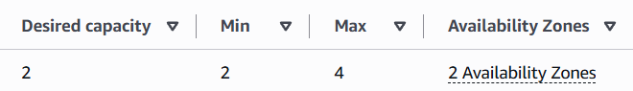
Figure 7: AWS console: capacity settings and availability zones
Both web servers are InService and Healthy on t3.micro. They run in different availability zones:
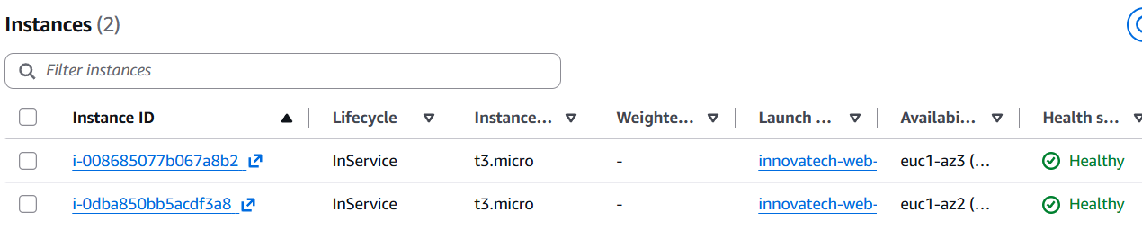
Figure 8: AWS console: the two web server instances in separate availability zones

5.2 Load Balancer and Target Group
Both web servers were registered by the Lambda using their private IPs (10.0.2.57 and 10.0.2.217), and both pass the load balancer’s health check.
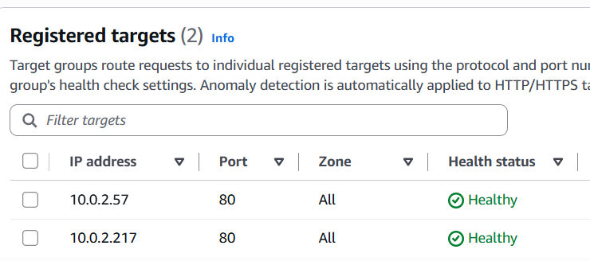
Figure 9: AWS console: both web servers registered and healthy in innovatech-web-tg
The load balancer is Active and Internet-facing.
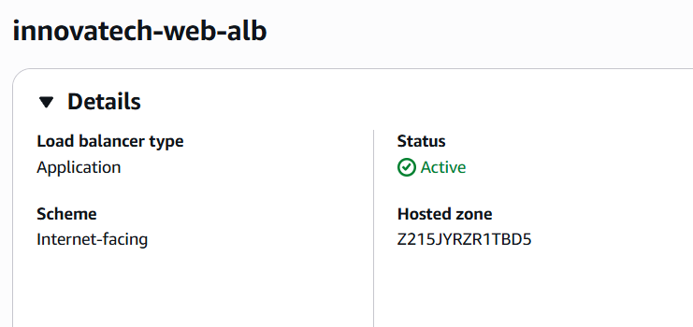
Figure 10: AWS console: innovatech-web-alb active and internet-facing
Its single listener on HTTP:80 forwards all traffic to the innovatech-web-tg target group.
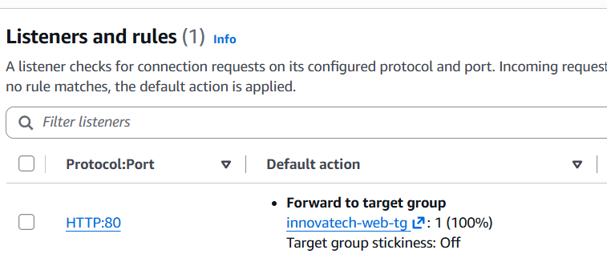
Figure 11: AWS console: HTTP:80 listener forwarding to the web target group

6. Website Working
The website can be seen opend in a browser using the load balancer’s public DNS name. The page shows which web server answered the request and the number of visits stored in the database. The visit count rose from 57 to 60 between the two screenshots. This shows that each page load is handled by a web server and written to the database: internet → load balancer → Transit Gateway → web server → database.
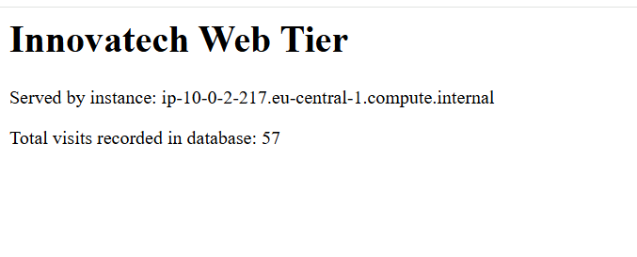
Figure 12: Website through the load balancer: served by a private web server, 57 visits recorded
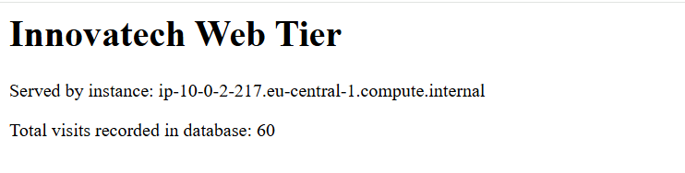
Figure 13: The same page after further requests: the visit count increased to 60

Summary
The front-end is fully defined in Terraform and built automatically: the launch template describes each server, and its user_data configures it. The Auto Scaling group keeps 2 to 4 servers running across two availability zones and replaces unhealthy ones. The internet-facing load balancer is the only public entry point and sends traffic only to healthy servers. Servers are added to and removed from it automatically through EventBridge and Lambda. The console screenshots confirm the deployment, and the live website shows the full path from the internet to the database working.

